EVOLT Common Support Inquires

- Logged out of Operator Panel/ Stuck on Control Panel

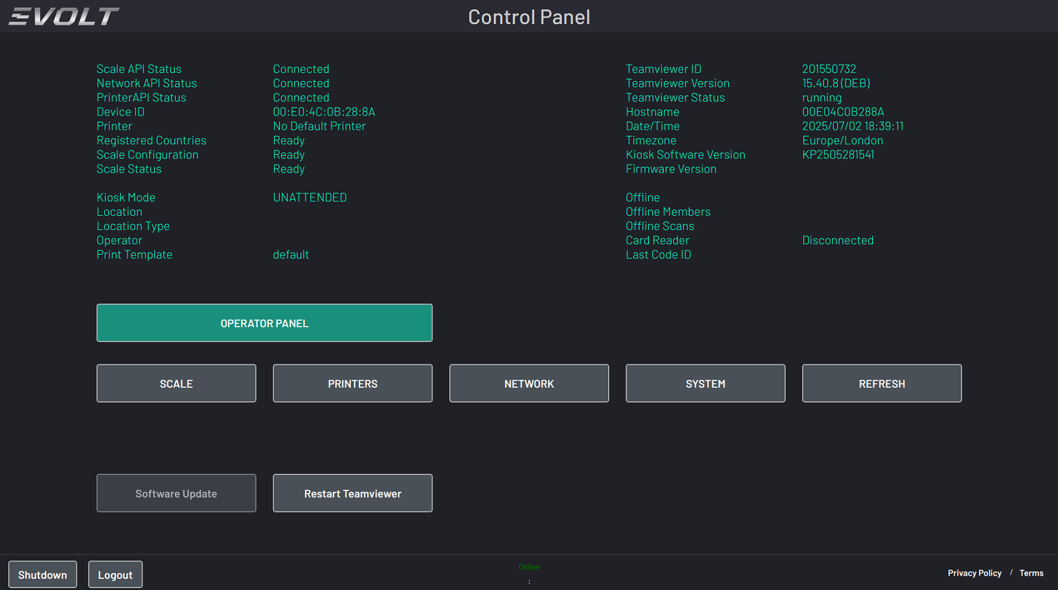

  - If the Scanner is stuck on the Control Panel/ No Red Start Scanning Button; this is commonly related to the scanner being logged out of its Operator Panel; you can see above the Location/Location Type and Operator Fields are blank; indicating being logged out
    - Connect the Scanner to the Internet if not already done (Wi-Fi or Ethernet)
    - Press the Operator Panel Button
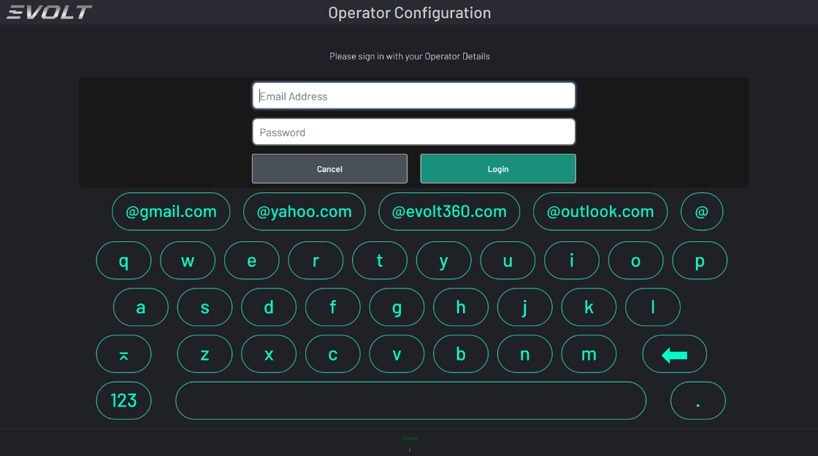
    - Enter in the Machine Credentials found on the Customer HubSpot Machine Deal
      - Example of how the username and password look: evoltchs@evolt360.com / evolt01

    - Select the Operator Configuration Options; Location from Drop down, Kiosk Mode (UNATTENDED), Print Setting and Volume (customer preference)

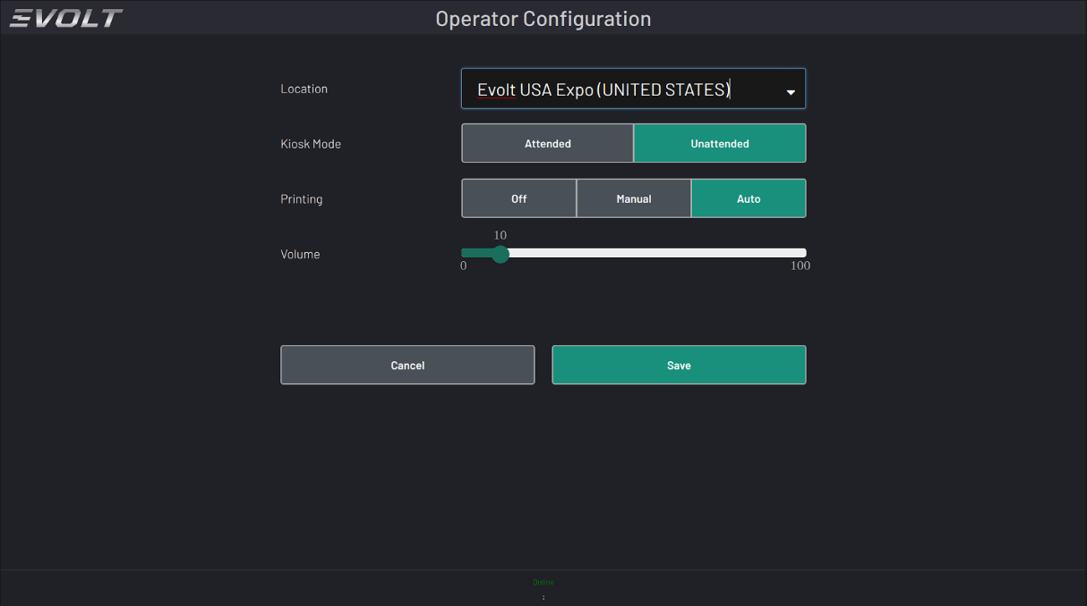
    - Press “Save”; this will bring you back to the Control Panel; but the missing field for the Location/Operator are now filled in.
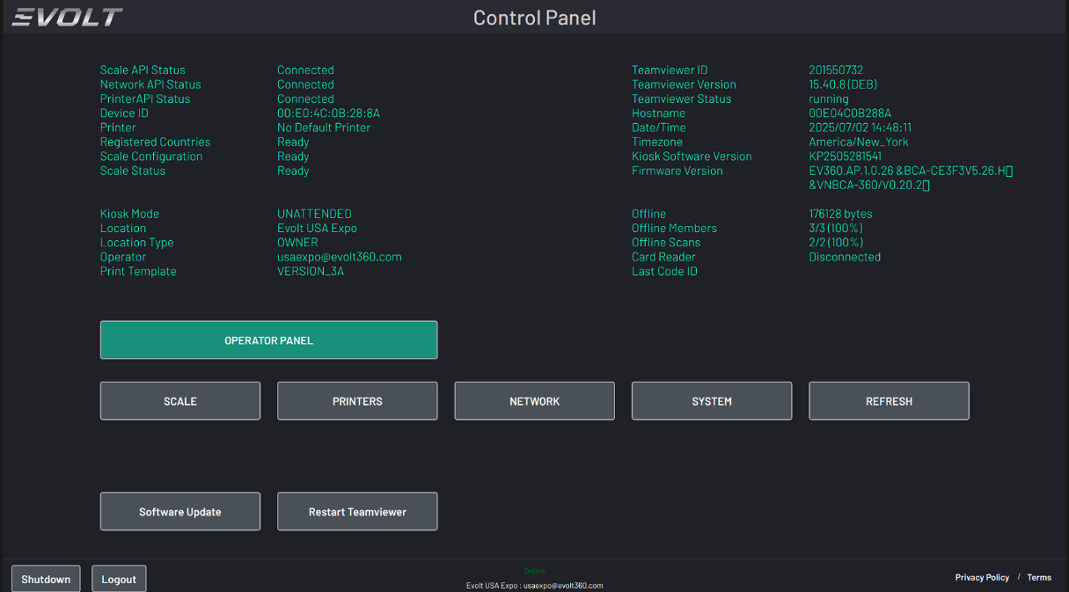
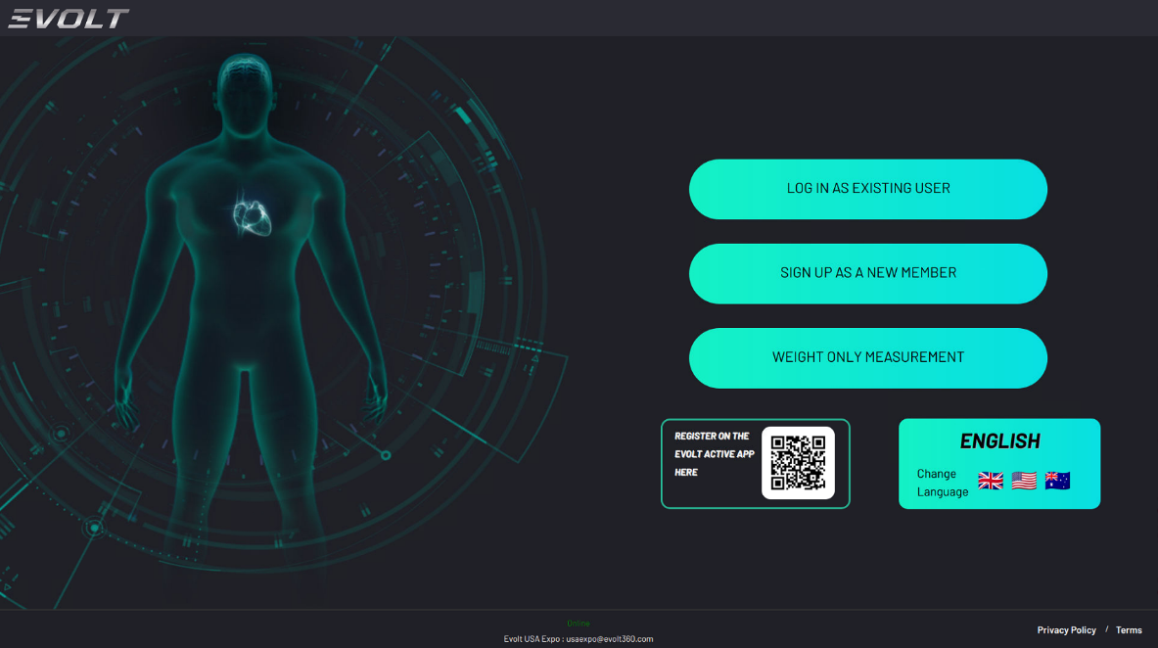
    - Press “Refresh” to bring you to the Home Screen

- Scale Calibration/ Weight is off or not reading any weight
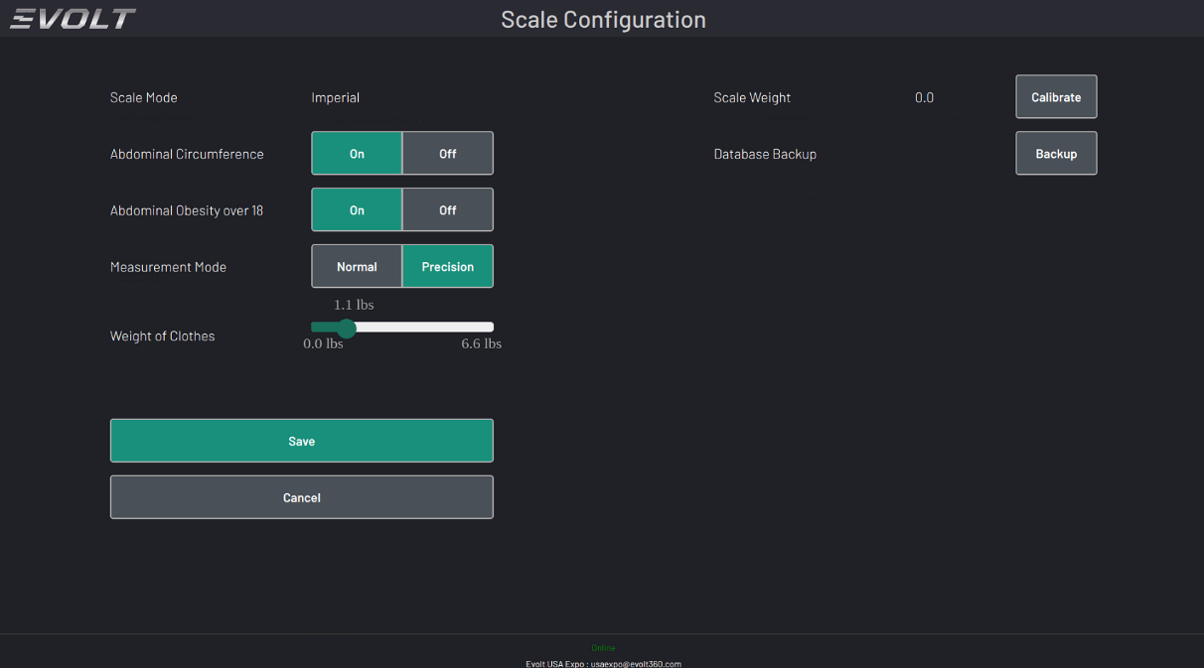
  - Check the Scale Settings from the Control Panel by Pressing the EVOLT logo in the upper left corner; then press the Scale Option
  - Weight should show 0.0; weight of clothing should be 1.1 lbs or .5 kgs
  - Press the “Calibrate” button to reset the Zero and then Press “Save” to save the settings.
  - Return to the Scale option; and have the customer use a known weight for accuracy testing. Items such as weight plates or dumbbells carefully placed on the scale are best as body weight can fluctuate.
  - If the weight is still inaccurate or not weighing any weight at all; escalate to the EVOLT Team for further troubleshooting

- Scanner Disconnected from the Internet
  - If the Scanner is not connected to the internet, navigate to the Control Panel
  - Press the Network Button
    - Ensure that “Wi-Fi is turned “ON” and that a New Connection Button is shown under Wi-Fi
    - Ensure that the Wi-Fi Dongle is plugged into one of the four USB Ports under the Screen in the back of the EVOLT
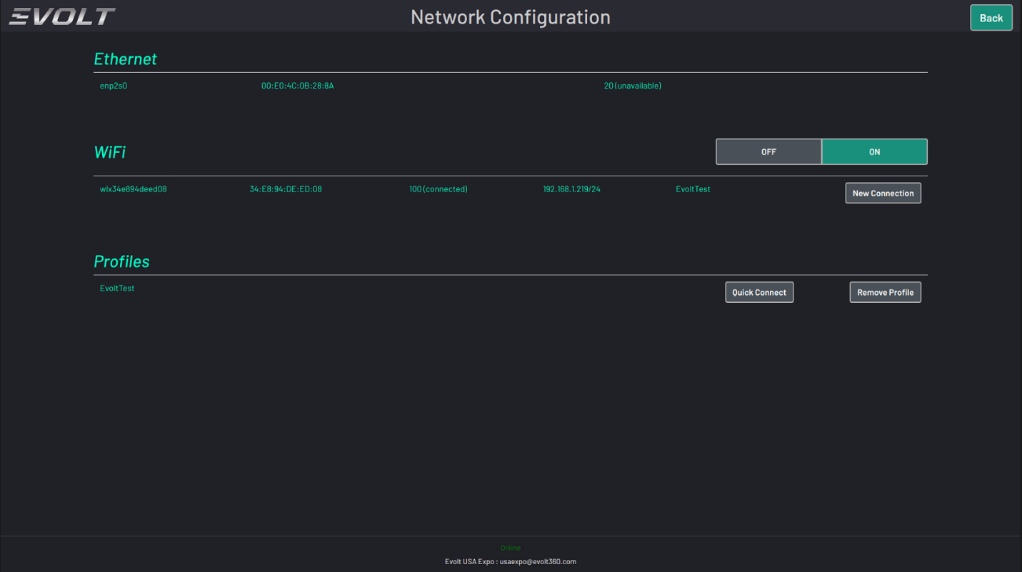
    - Select New Connection; have the customer find the desired Network and select that and enter in the password
    - Once connected it should show 100(connected) as well as save the profile under “Quick Connect”
    - If using ethernet; simply plug the ethernet cord into the ethernet port on the back of the unit; and it should automatically connect.

- USB Lock Turned On- Resulting in No New Connection Button for WiFi
  - If the Wi-Fi Option does not show a “New Connection” Button, and the dongle is present in the back of the unit
    - Navigate to the Control Panel and Press the “System” button
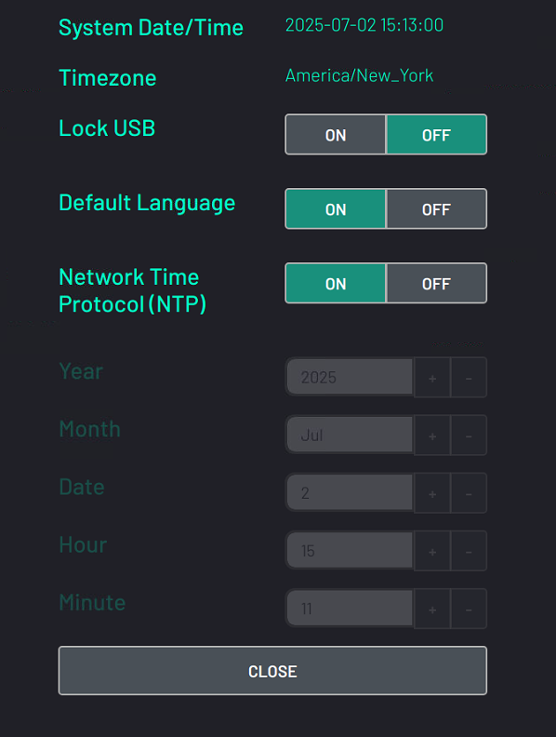
    - If the USB lock shows to be toggled “ON”, have the customer switch it to “OFF”, Press “Close” and then power cycle the EVOLT
    - After the unit restarts, check the USB lock is “OFF” and that the “New Connection” option is showing in the Network Settings.
    - This can also effect a VTAP Reader or Printer Cable not being picked up by the system; so if a device is not found via USB connection, first step is to check the USB Lock setting.
    - If the device is online via ethernet; you can turn the USB Lock off; the run the command (sudo supervisorctl restart all) in the command terminal via teamviewer; and that will also do as if you rebooted the unit after switching the setting to “Off”

- Printer is not printing Result Sheet after a Scan
  - If a customer’s printer is not printing Result Sheets after a scan; check the following settings:
    - Printer setting is set to either Manual or Auto in the Operator Configuration Settings
    - Log into the Operator Panel using the Machine Logins
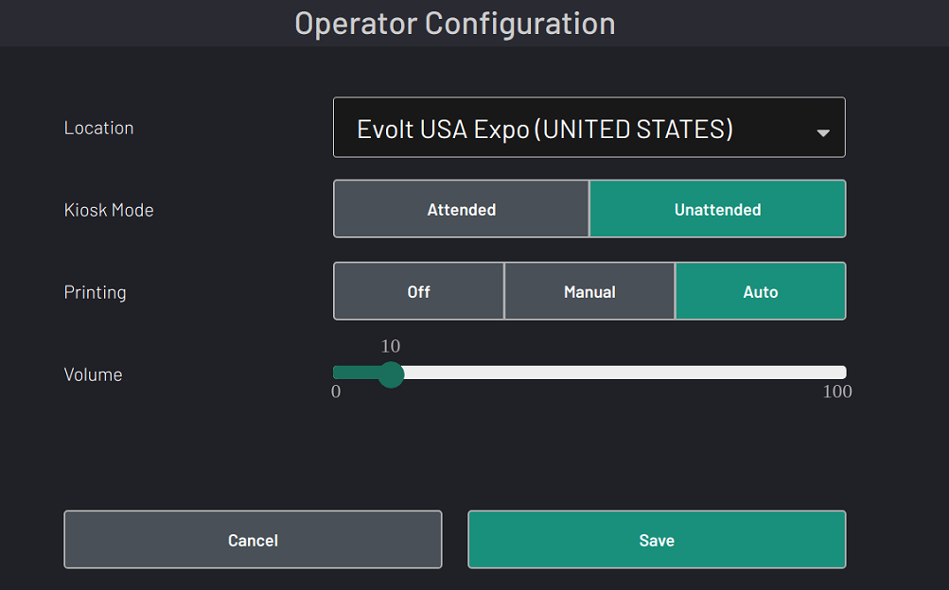
    - Ensure Print setting is not set to “OFF”
  - Printer Configuration and Setup:
    - Select Printers from the Control Panel
    - Hit “Add Printer to configure the device; either via a USB or Wi-Fi
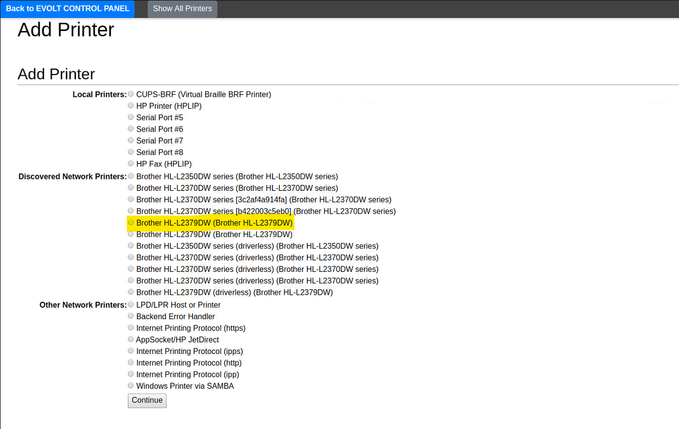
    - Select the correct Printer
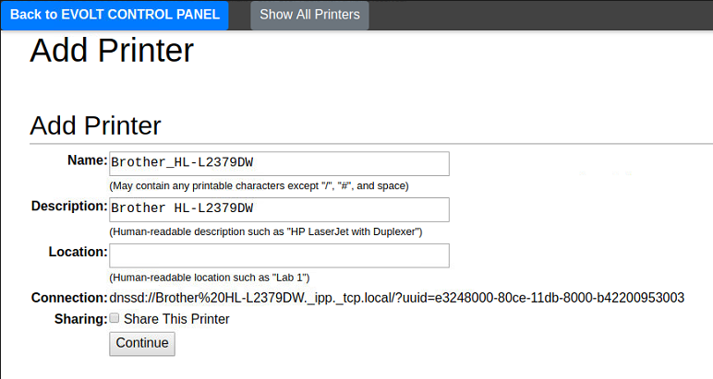
    - Hit Continue on the next page
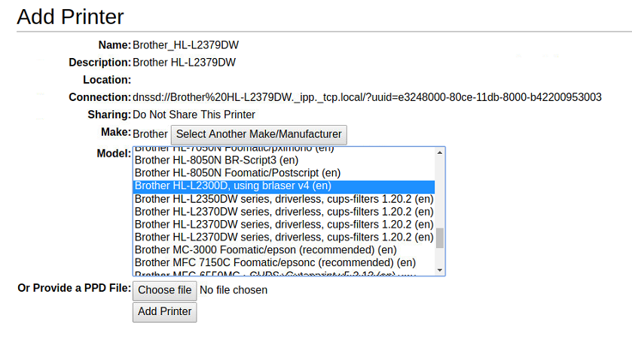
    - Select the correct Driver:

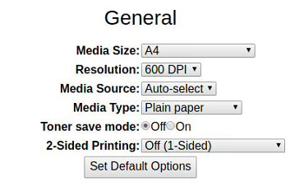
    - Hit “Add Printer”
    - Set the Default settings; only change needed is if the Paper is A4 or US Letter. All locations should be A4 unless they are based in the United States
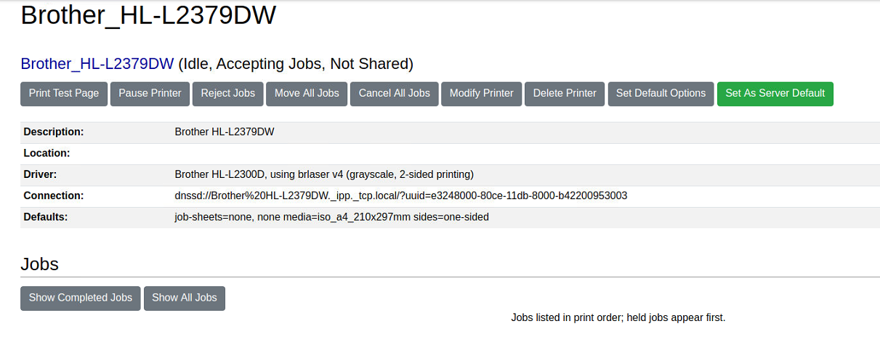
    - Set the Printer as the Server Default from the Properties Page
    - Have the customer complete a test scan and ensure it prints as expected

- Screen on the Scanner is Frozen / No response from any Buttons
  - If the Scanner is not responding to touch to conduct a scan; check that the “Partner Mode” may be enabled. A small faint grey circle on the home page will be in the upper right-hand corner if it is.
    - Have the customer tap the circle and enter in the password for their Machine Operator Credentials; for example, Anytime Fitness Operator Passwords are almost always af01.
    - Once the password is entered; it should then illuminate the circle; allowing them to now interact with the scanner and complete one scan. After the scan is completed, the screen will again lock.
    - The only button on this home screen that will work; is the EVOLT logo in the upper left corner to navigate to the Control Panel
  - If the pin code is not working; and the password is being used correctly:
    - Have the customer navigate to the Control Panel and log out of their Operator Account.
    - Then have them log back into the Operator Panel; and attempt the passcode again.
    - If the issue persists escalate the issue to the EVOLT Team.

- EVOLT Won’t Power On
  - If the EVOLT will not power on; check the following:
    - Ensure that the power cord is fully seated into the power pack and plugged into the outlet/surge protector (always recommended to customers to use one)
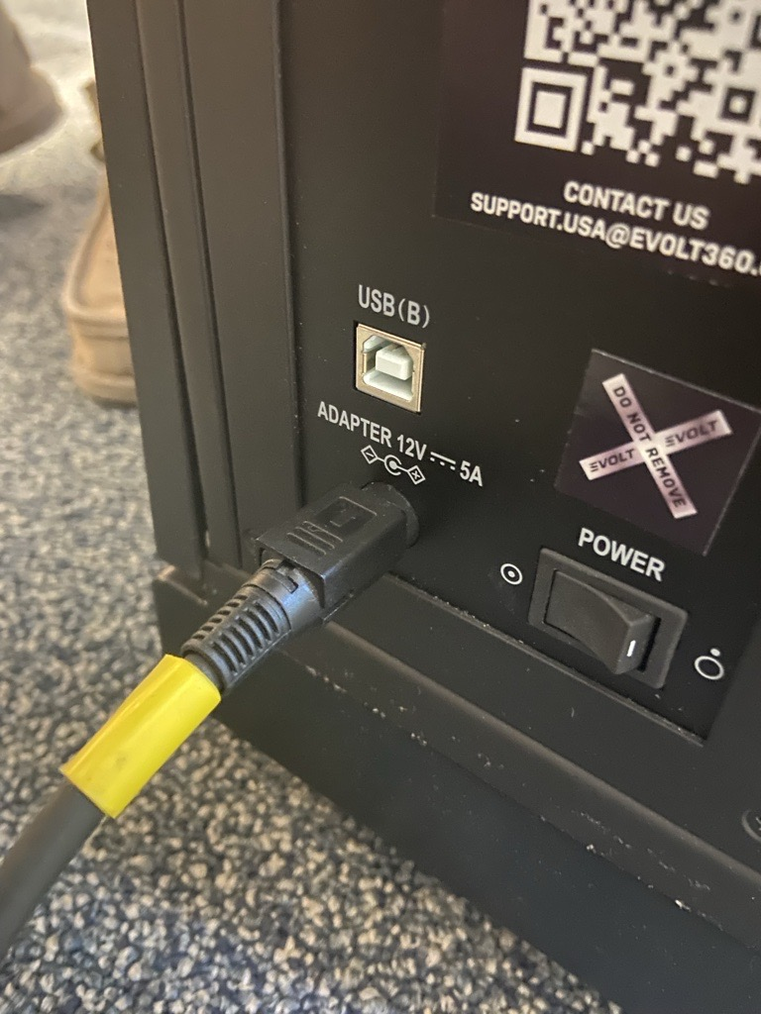
    - Ensure that the power cord position into the unit is correct as shown below:
    - The power cord port must have the flat side facing up
    - The switch; “ON” Position is the with circle with the dot inside of it
  - If all of this is correct; and the unit still does not power on have the customer check for any lights coming on from the vents under the screen.
    - If lights are showing; then this indicates an issue likely from the Power Board; or the Mother Board since power is being received; this will require the EVOLT Team to coordinate a repair.
    - If lights are not showing; most commonly this means the power cord/pack are bad and need to be replaced; escalate to the EVOLT team to coordinate the power pack replacement.

- EVOLT is Stuck on a White Screen
  - If the EVOLT Scanner goes to a white screen and stays on the white screen for more than 1 minute; have the customer wait 10 minutes for the debugging tool to attempt to recover the system.
  - If after 10 minutes the screen is still stuck on the White Screen; we can do the following:
    - Sometimes we can still remote into the unit if we have the TeamViewer ID documented on their HubSpot Profile and if the unit is on; and still has an active internet connection.
    - If this is the case; and we can remote into the White Screen; we can run a software update via Scripts through the Command Terminal
      - Prompts:
        - sudo rm -rf linuxkioskinstall.tar.bz2
        - sudo wget https://evoltactive.com/active/releases/linuxkioskinstall.tar.bz2
        - sudo tar -xvjf linuxkioskinstall.tar.bz2
        - cd linuxkioskinstall
        - sudo ./install.sh
          - This will install and reboot the unit; which should recover the system and go back to the Control Panel/Home Page. After this; clean up the disk using:
          - sudo rm -rf linuxkioskinstall.tar.bz2
  - If we cannot remote login to the unit; we can send the files for the customer to download; or have the EVOLT Team send a pre-loaded USB to site to run a Re-Image of the Software on the unit. This will require a 16GB USB and a keyboard that can be plugged into the scanner.

- Member cannot log into EVOLT to Scan
  - If the member is an existing EVOLT Account holder; have them login to their mobile application; and check that the phone number they are using on the scanner to sign in matches the details in the mobile application.
    - If the number in the mobile application is “incorrect” they can update it in the application. Ensure that the only characters in the phone number are numerical; any character such as + or () will throw off the login ability.
  - If the member is new to EVOLT; but the scanner is saying the email they are using to sign up already has an account; they likely have made an account in the past. They can request a password reset from the mobile app or you can send it from this webpage of the web app by putting in their email to forgot password option send the link
    - EVOLT IOH

